Section 4 – Saving & Loading

4.1 Design

This section will contain the systems needed to save, load, import and export images. This will be able to export the image created by the previous section:

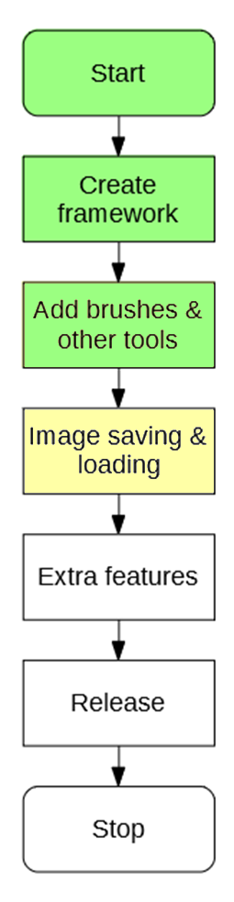

# 4.1.1 Success Criteria Fulfilment Plan

In this section the following success criteria are planned to be completed:

Not completed

To be done this section

Completed

|  |  |  |
| --- | --- | --- |
| **Feature** | **Proof** | **Code** |
| Section A - Brushes | | |
| Variable brush width | Screenshot of strokes of the same brush showing different widths | A1 |
| Hard brushes | Screenshot showing the hard edge of the brush (colour to no colour) | A2 |
| Shape creation tools | Screenshot showing the shape toolbar and a small selection of drawn shapes | A3 |
| Fill (bucket) tool | Screenshot showing a before and after of filling a large area | A4 |
| Single pixel pencil | Screenshot showing a stroke of the single pixel brush | A5 |
| Rubber | Screenshot showing a densely packed picture being rubbed out | A6 |
| Section B – Other editing tools | | |
| Image viewer | Screenshot of a currently being viewed image | B1 |
| Bitmap image editor | Screenshot of a zoom in on the image showing the pixels | B2 |
| RGB colour picker | Screenshot showing a system for entering an RGB colour | B3 |
| RGB direct input | Screenshot showing the user entering “FF0000” (or equivalent) and the programming outputting red | B4 |
| Layer system | Screenshot of layer navigator | B5 |
| Rectangle selection tool | Screenshot showing a rectangle selection on the image | B6 |
| Magic selection tool | Screenshot showing a complex selection around non-linear shape | B7 |
| Transparent pixels | Screenshot showing a layer with blank pixels (one layer on top of another). Partial transparency is not required | B8 |
| Zoom in (no zoom out) | Screenshot of an image at smallest zoom, followed by a screenshot at max zoom showing a portion of an image much smaller | B9 |
| Text | Screenshot of the text “Hello World” on the image | B10 |
| Eyedropper tool | Screenshot of an imported image, with the colour stroke of a colour taken from that image beneath it | B11 |
| *Image effects* | *Screenshot of an image before and after an effect is applied* | B12 |
| *Rotating Images* | *Screenshot of an image in 4 different rotations, normal, 90°, 180° and 270°* | B13 |
| *Clipping masks* | *Screenshot of an image being clipped onto a complex selection* | B14 |
| Section C – File System | | |
| Creating a new image | Screenshot of a blank 300x300 square image | C1 |
| Importing images | Screenshot of the file browser showing an image preview, and screenshot showing the image in the program | C2 |
| Exporting images | Screenshot showing a custom image in the program, followed by an image showing the file browser showing the image in a folder | C3 |
| Supporting PNG and JPEG | Screenshot showing the file browser which accepts both PNG and JPEG images | C4 |
| Saving and loading from a proprietary format | Screenshot showing the user saving an image, screenshot of the image in the file browser, and the program after the image is loaded | C5 |
| Section D – Usability | | |
| Program should be stable and not crash. | A complete testing table, showing no failed tests, followed 75% yes response to asking stakeholders “Did you encounter any errors while using the program?” | D1 |
| Program should be easy to use | 75% yes response to asking stakeholders “Did you find the program easy to use?” | D2 |
| Features should be easily accessible | From the default state of the program, any feature will need to be activated by no less than 4 clicks | D3 |

# 4.1.2 Saving a file

Before loading must come saving. This is where all of the necessary contents of the image are exported onto a file on disk, which can be opened again by the program and contain **no loss of necessary information**. This means that some info (such as the last brush colour used) is not important and can be lost.

## File Plan

To save the file, the program must save into a file:

HEADER:   
 IMAGE HEIGHT  
 IMAGE WIDTH  
 NUMBER OF LAYERS  
  
BODY:  
 TOP LAYER:   
 COLOUR OF (0,0)  
 COLOUR OF (1,0)  
 ...  
 COLOUR OF (width-1,height-1)  
  
 SECOND LAYER:   
 COLOUR OF (0,0)  
 COLOUR OF (1,0)  
 ...  
 COLOUR OF (width-1,height-1)  
  
 ...  
  
 LAST LAYER:   
 COLOUR OF (0,0)  
 COLOUR OF (1,0)  
 ...  
 COLOUR OF (width-1,height-1)

This file plan contains two main parts, the Header and Body. This is similar to the form of a HTML page.

* Header will be fixed in size and contain the width and height of the image.
  + The dimensions are needed so that when the program is reading from the file, it knows that for each layer it must load width * height pixels.
  + The number of layers are needed so that when the program is reading from the file, it knows how many times to load a layer.
* Body will be variable in size and will contain the information about each layer of the image.

## Header Pseudocode

Writing to the header should be a reasonably simple affair.

PROCEDURE WriteHeader(file) {  
 file.Write(image.width)  
 file.Write(image.height)   
 file.Write(image.layers.count)  
}

## Body Pseudocode

Writing the body should be also simple, though a lot more data will be written:

PROCEDURE WriteBody(file) {  
 FOR EACH layer IN image.layers  
 FOR x = 0 TO image.width  
 FOR y = 0 to image.height  
 color = layer.GetColor(x,y)  
 file.Write(color.R)   
 file.Write(color.G)   
 file.Write(color.B)  
 NEXT y  
 NEXT x  
 NEXT layer  
}

Writes R, G, and B as three separate values

This makes saving to the file a much simpler task

# 4.1.3 Loading a file

Loading from the file may be a more difficult task, as there is only raw binary to work with. However with reference to the file plan it should be obvious how to load the file.

## Header Pseudocode

Assuming there are three values in the file, loading should be a simple affair:

PROCEDURE LoadHeader(file) {  
 imageWidth = file.Read()  
 imageHeight = file.Read()  
 layerCount = file.Read()  
}

## Body Pseudocode

After reading the values from the header, it becomes possible load the next of the file like so:

PROCEDURE LoadBody(file) {  
 FOR i = 0 TO layerCount  
 layer = new Layer(imageWidth, imageHeight)  
 FOR x = 0 TO imageWidth  
 FOR y = 0 TO imageHeight  
 R = file.Read()  
 G = file.Read()  
 B = file.Read()  
 layer.SetPixel(new Color(R,G,B))  
 NEXT y  
 NEXT x  
 NEXT i  
}

## Handling Invalid Files

The previous code assumes that the file has not been corrupted at any point. Potential errors that may be thrown (and thus handled) are:

* EndOfStreamException, for if the file has ended prematurely.
* InvalidParameterException, if R, G or B is incorrect when creating the new colour.

So then, to make the file safe to load, the following **try-catch** blocks can be implemented to handle these sorts of errors, in the LoadBody procedure:

PROCEDURE LoadBody(file) {  
 FOR i = 0 TO layerCount  
 layer = new Layer(imageWidth, imageHeight)  
 FOR x = 0 TO imageWidth  
 FOR y = 0 TO imageHeight  
 try {  
 R = file.Read()  
 G = file.Read()  
 B = file.Read()  
 } catch EndOfStreamException {  
 break;  
 }  
 try {  
 layer.SetPixel(new Color(R,G,B))  
 } catch InvalidParameterException {  
 layer.SetPixel(new Color(0,0,0))  
 }  
 NEXT y  
 NEXT x  
 NEXT i  
}

As soon as the end of the file is reached, stop reading

# 4.1.4 Exporting to a PNG

This is quite a simple operation. In C# there exists a method of the Bitmap class (which is created when the display requires an image) which saves an image to a file. This will be used to avoid **reinventing the wheel**, and as the algorithms behind many popular image formats are elaborate and out of the scope of the project.

The user must also be able to tell the program where to save the image. This can be done by using an existing part of the .NET library, the file browser. This is used instead of a proprietary browser as the file system can be complex, and the Windows browser can use its own features such as favourites.

SIMP is an image editing program, not a file browsing program.

So thus the code for exporting is:

PROCEDURE export() {  
 Prompt user for where to save file  
 saveBitmap = image.RequestBitmap()  
 saveBitmap.save()  
}

# 4.1.5 Importing from a PNG

Importing as much the same as exporting, as C# also contains inbuilt classes for this purpose. However once the image has been encapsulated into a bitmap, it must be placed onto the image. This can be done by creating a new layer, and transposing each pixel of the file onto the image, or check each pixel of the image. This is because if the file is much bigger than the image, then it would be expensive to iterate through each pixel in the image if it is mostly invisible:

For example, if the red rectangle is the image, and the blue rectangle is the file trying to be imported:

Then it is clearly impractical to loop through each pixel of the file.

To decide which way around to iterate, a **heuristic** can be used. By finding the area of the image and file, a good guess can be made as to which one to iterate through (the one with the smaller area). This can be used to make sure that file loading is fast for larger images.

Thus the algorithm becomes:

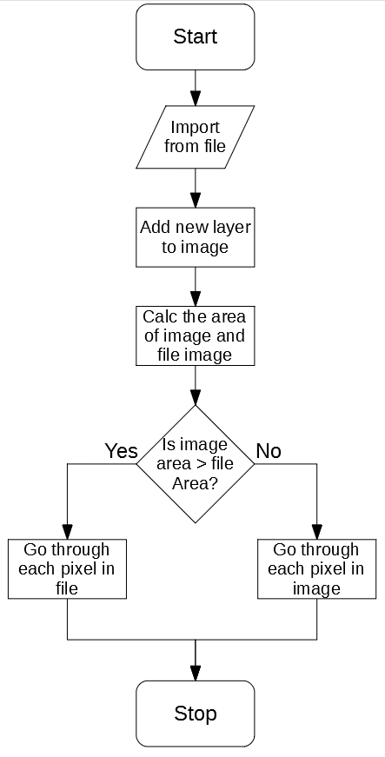

# 4.1.6 New GUI design

When creating images like this, some new GUIs may be needed. The most important one being the dialogue to create an image:

New Image

Width

Height

Create

This will be started whenever a new image is needed to be made.

4.2 Development

# 04/12/2019 Form Design

The buttons necessary for the designed functions have been added to the form:

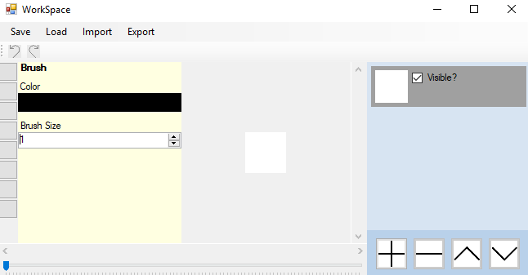

Stakeholders agreed that the top was a reasonable place to put those buttons, similar to other programs.

# 06/12/2019 Saving File

## Writing algorithm

When saving the file, there are two potential classes that can be used for saving to a file; StreamWriter or FileStream.

StreamWriter allows saving of ASCII code to a file, FileStream saves raw binary. StreamWriter produces more easily readable files, but is less efficient as all numbers are encoded in ASCII. **I have decided** to use the FileStream class to reduce the file size of SIMP files and increase loading speed.

After this, the file saving algorithm can be implemented:

PROCEDURE WriteBody(file) {  
 FOR EACH layer IN image.layers  
 FOR x = 0 TO image.width  
 FOR y = 0 to image.height  
 color = layer.GetColor(x,y)  
 file.Write(color.R)   
 file.Write(color.G)   
 file.Write(color.B)  
 NEXT y  
 NEXT x  
 NEXT layer  
}

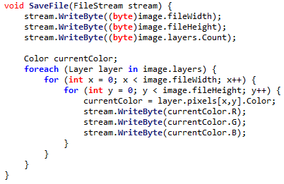

## Header Error

After programming the header, an error was detected. It occurred when one of the dimensions of the image was greater than 255. As this could not be saved into one byte, an error was thrown.



This can be fixed by using two bytes each to store the width and height. This means that maximum size is increased from 255 to 255² (65,025), which is much larger than the maximum size. Whilst this may waste space for smaller images, the extra space needed is so minute that this is unlikely to be an issue.

It’s assumed that 255 layers will never be created, so the same sort of error checking is not needed there.

This makes the new code for saving:

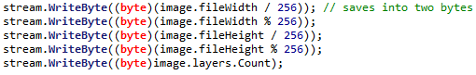

# 9/12/2019 More robust importing

Image importing has now been implemented according to 4.1.2, but it is currently not very robust. This especially happens when a non-SIMP file is attempted to be loaded.

This can be resolved by attaching the values 0x53, 0x49, 0x4D, 0x50 to the start of the file. This is the ASCII code for ‘SIMP’. Thus when the file is attempting to be loaded, the program will check the first four bytes to see if they are ‘SIMP’.

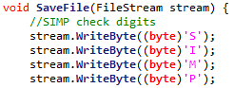

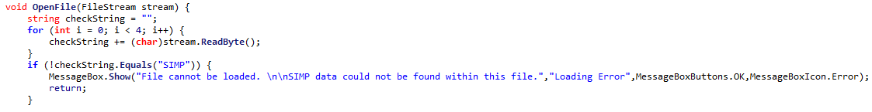

This means non SIMP files will not be loaded.

# 10/12/2019 Importing & Exporting

Image importing and exporting can now be introduced.

These both use C# base classes for importing & exporting, as the algorithms tied with PNG, JPEG and BMP are complex. Implementing these would be far outside the scope of the project, so it is suitable to use them here.

# 11/12/2019 Stakeholder feedback

After giving the program to my stakeholders, they had the following feedback:

“Images should be imported to be centred in the image”

“Exporting while the image is zoomed doesn’t work”

“Image should be the same size as the canvas”

“You should be able to open an image from the start page”

## Fixing Exporting

When the image is exported whilst the image is zoomed in, a zoomed in portion of the image was exported instead:



To fix this, the zoom of the image is temporarily set to 1, then exported. This means the proper image is always exported:

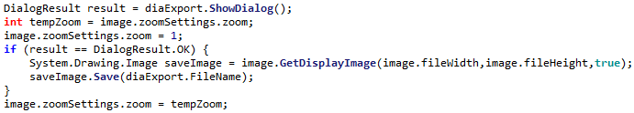

## Fixing Importing

The importing however turned out to be quite flawed, for most images the result would be:

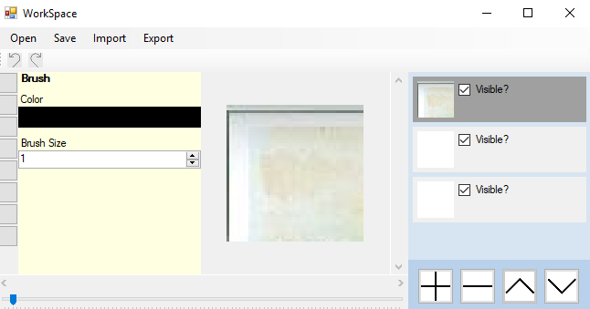

So, a different importing system needs to be used. A similar system to the one used for drawing the layer preview, where a foreach is used on each pixel of the image.

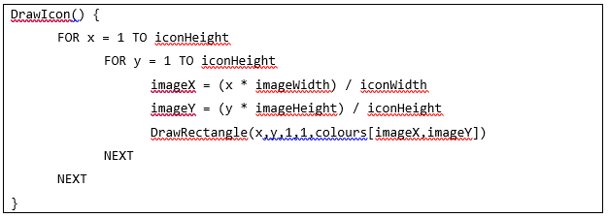

Changing the code for importing to:

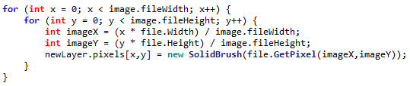

This means that images can now be properly imported:

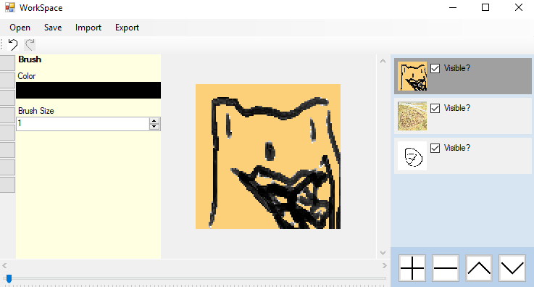

## Improving Start page

Currently the start page for SIMP is very basic, only allowing to create an image, and without any options to import or open an existing SIMP file:

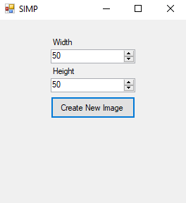

So, a few more buttons have been requested by the stakeholders:

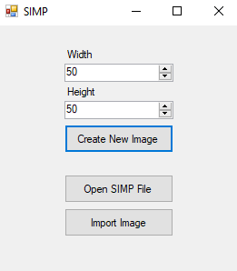

Opening an existing SIMP file is reasonably simple, it can use the existing open file function designed before.

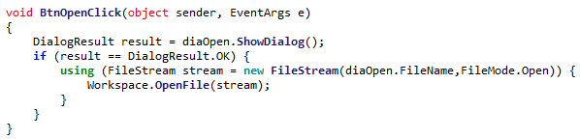

However importing an image will need to be designed slightly differently

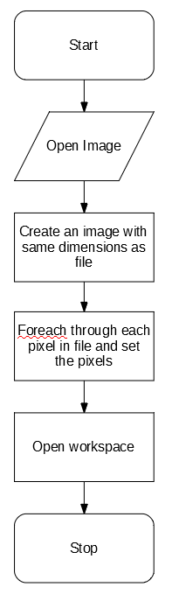

After doing this, the start page is fully functional.

# 14/12/2019 Improvements to saving

## Implementing Save As

The top bar currently only contains a Save button, which always makes a new file. This is not always useful if the user wants to save updated changes. The top bar has been updated to now include Save and Save As buttons:

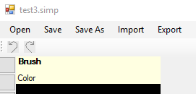

Notification boxes have also been added upon saving or exporting an image:

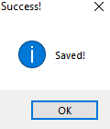

# 4.2.1 Success Criteria Evaluation

After these developments, Section 4 is now complete. The success criteria can now be evaluated

|  |  |  |
| --- | --- | --- |
| **Feature** | **Proof** | **Code** |
| Section C – File System | | |
| Importing images | Screenshot of the file browser showing an image preview, and screenshot showing the image in the program | C2 |
| Exporting images | Screenshot showing a custom image in the program, followed by an image showing the file browser showing the image in a folder | C3 |
| Supporting PNG and JPEG | Screenshot showing the file browser which accepts both PNG and JPEG images | C4 |
| Saving and loading from a proprietary format | Screenshot showing the user saving an image, screenshot of the image in the file browser, and the program after the image is loaded | C5 |

Not completed

Completed

|  |  |  |
| --- | --- | --- |
| **Feature** | **Proof** | **Code** |
| Section A - Brushes | | |
| Variable brush width | Screenshot of strokes of the same brush showing different widths | A1 |
| Hard brushes | Screenshot showing the hard edge of the brush (colour to no colour) | A2 |
| Shape creation tools | Screenshot showing the shape toolbar and a small selection of drawn shapes | A3 |
| Fill (bucket) tool | Screenshot showing a before and after of filling a large area | A4 |
| Single pixel pencil | Screenshot showing a stroke of the single pixel brush | A5 |
| Rubber | Screenshot showing a densely packed picture being rubbed out | A6 |
| Section B – Other editing tools | | |
| Image viewer | Screenshot of a currently being viewed image | B1 |
| Bitmap image editor | Screenshot of a zoom in on the image showing the pixels | B2 |
| RGB colour picker | Screenshot showing a system for entering an RGB colour | B3 |
| RGB direct input | Screenshot showing the user entering “FF0000” (or equivalent) and the programming outputting red | B4 |
| Layer system | Screenshot of layer navigator | B5 |
| Rectangle selection tool | Screenshot showing a rectangle selection on the image | B6 |
| Magic selection tool | Screenshot showing a complex selection around non-linear shape | B7 |
| Transparent pixels | Screenshot showing a layer with blank pixels (one layer on top of another). Partial transparency is not required | B8 |
| Zoom in (no zoom out) | Screenshot of an image at smallest zoom, followed by a screenshot at max zoom showing a portion of an image much smaller | B9 |
| Text | Screenshot of the text “Hello World” on the image | B10 |
| Eyedropper tool | Screenshot of an imported image, with the colour stroke of a colour taken from that image beneath it | B11 |
| *Image effects* | *Screenshot of an image before and after an effect is applied* | B12 |
| *Rotating Images* | *Screenshot of an image in 4 different rotations, normal, 90°, 180° and 270°* | B13 |
| *Clipping masks* | *Screenshot of an image being clipped onto a complex selection* | B14 |
| Section C – File System | | |
| Creating a new image | Screenshot of a blank 300x300 square image | C1 |
| Importing images | Screenshot of the file browser showing an image preview, and screenshot showing the image in the program | C2 |
| Exporting images | Screenshot showing a custom image in the program, followed by an image showing the file browser showing the image in a folder | C3 |
| Supporting PNG and JPEG | Screenshot showing the file browser which accepts both PNG and JPEG images | C4 |
| Saving and loading from a proprietary format | Screenshot showing the user saving an image, screenshot of the image in the file browser, and the program after the image is loaded | C5 |
| Section D – Usability | | |
| Program should be stable and not crash. | A complete testing table, showing no failed tests, followed 75% yes response to asking stakeholders “Did you encounter any errors while using the program?” | D1 |
| Program should be easy to use | 75% yes response to asking stakeholders “Did you find the program easy to use?” | D2 |
| Features should be easily accessible | From the default state of the program, any feature will need to be activated by no less than 4 clicks | D3 |